ROSSMOYNE SHS

Semester 1 2010 Examination

MATHEMATICS 2A
Section Two: Calculator-assumed

STUDENT’S NAME _____________________________________

TEACHER:-
(Circle one name) FLETCHER TANDAY

Time allowed for this section
Reading time before commencing work: 10 minutes
Working time for this section: 100 minutes

Material required/recommended for this section

To be provided by the supervisor
This Question/Answer Booklet
Formula Sheet (retained from Section One)

To be provided by the candidate
Standard items: pens, pencils, pencil sharpener, eraser, correction fluid, ruler, highlighters

Special items: drawing instruments, templates, notes on two unfolded sheets of A4 paper, and up to three calculators satisfying the conditions set by the Curriculum Council for this course.

Important note to candidates
No other items may be taken into the examination room. It is your responsibility to ensure that you do not have any unauthorised notes or other items of a non-personal nature in the examination room. If you have any unauthorised material with you, hand it to the supervisor before reading any further.

Structure of this paper

Section | Number of questions available | Number of questions to be answered | Working time available  (minutes) | Marks available
Section One:  Calculator-free | 7 | 7 | 50 | 40
Section Two:  Calculator-assumed | 15 | 15 | 100 | 80
 |  |  |  | 120

Instructions to candidates

1. The rules for the conduct of Western Australian external examinations are detailed in the Year 12 Information Handbook 2010. Sitting this examination implies that you agree to abide by these rules.

2. Write your answers in the spaces provided in this Question/Answer Booklet. Spare pages are included at the end of this booklet. They can be used for planning your responses and/or as additional space if required to continue an answer.
  - Planning: If you use the spare pages for planning, indicate this clearly at the top of the page.
  - Continuing an answer: If you need to use the space to continue an answer, indicate in the original answer space where the answer is continued, i.e. give the page number. Fill in the number of the question(s) that you are continuing to answer at the top of the page.

3. Show all your working clearly. Your working should be in sufficient detail to allow your answers to be checked readily and for marks to be awarded for reasoning. Incorrect answers given without supporting reasoning cannot be allocated any marks. For any question or part question worth more than two marks, valid working or justification is required to receive full marks. If you repeat an answer to any question, ensure that you cancel the answer you do not wish to have marked.

4. It is recommended that you do not use pencil except in diagrams.

SECTION TWO
Question 1 [1, 2, 3 = 6 marks]

  - Find 30% of 6.8kg

  - If 30% of an amount is $375, find the amount

  - When an amount is increased by 10% and the amount obtained is then decreased by 10%, what percentage of the original is the final amount.

Question 2 [2, 2 = 4 marks]
The exchange rate between Pounds (₤) and the Australian Dollar (A$)
is 1.6A$ per ₤.
  - Determine the cost in ₤ to the nearest penny (100 pence in a pound), for a jacket bought for A$100.

  - Which costs more, a shirt for A$45 or trousers for ₤18.

Question 3 [2, 3 = 5 marks]
- Find the value missing number for the following pyramid pattern.
9 |  | 6 |  |  |  | 8
 | 15
 |  |  |  |  |  |  |  | Same number contained in each of these boxes
 |  |  |  | 100

The value of the number =

- Find the value of x for the following pyramid pattern.
7 |  | x |  |  |  | 3 |  | 5
 |  |  | 4x |  |  |  | 8
 |  |  |  | 90

The value of x =
Question 4 [3 marks]

The nutritional information on the side of a box of Weet-Bix states that a 35g serve contains 5.6g fibre. The information on a box of Sultana Bran states that a 45g serve contains 6.4g of fibre. By showing below how to calculate the percentage of fibre in each of the two cereals, state which cereal is higher in fibre.

Question 5 [3, 2 = 5 marks]
Jo had $100 and Frank had $200 before they went shopping.
Between them they spent $125.
- If Frank ended up with four times as much money as Jo, how much did Jo spend and how much did Frank spend.

- Show as a percentage how much each spent of their own money.

Question 6 [2, 3 = 5 marks]

Tim’s fishing boat leaves the harbour and travels 3.8km due North; Tom’s boat leaves the harbour and travels due East for 2.9km.

  - Draw a diagram of this situation

  - How far apart are the 2 boats at this time

Question 7 [4 marks]
A

In the diagram, BC = 33 mm, CD = 44 mm,
D
AB = 73 mm. ∠BCD = ∠BDA = 90°

Calculate the length of AD.

C B

Question 8 [ 3, 2 = 5 marks]
A tall thin vertical mast of height 34m stands with its
base at the centre of a level concrete square of side 20m.

- Calculate the distance from one corner of the base
to the bottom of the mast.

- Hence calculate the distance from that corner to the top of the mast.

Question 9 [1, 1, 2, 2 = 6 marks]

Two electricians, Eddie and Dale, charge for their work according to the formulas

Eddie: 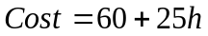 Dale: 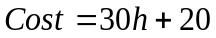

where h stands for the number of hours of work they do.

- How much would Eddie charge for a job taking 5 hours.

- Dale did a job which cost $140. How long did it take.

- For a job taking 12 hours, who is the cheapest and by how much.

- On one occasion, Eddie and Dale charge the same amount for a similar job.
How many hours of work do they both have to do.

Question 10 [1, 1, 2, 2 = 6 marks]

A school held a basketball shooting competition. The number of attempts for girls and boys to score their first basket was recorded and this data is summarised in the table below.
Number of attempts | Boys | Girls
1 | 25 | 20
2 | 20 | 13
3 | 15 | 9
4 | 6 | 2
5 | 4 | 1

- How many boys took part in the competition.

- What percentage of those who took part were girls.

- By comparing the mean number of attempts for boys and girls, state whether the boys or the girls were better at basketball shooting.

- Calculate the mean number of attempts for the combined group of boys and girls, giving your answer to two decimal places.
Question 11 [2, 4 = 6 marks]

- The table below shows the expenditure of a small business over a three month period. The owner of the business wants to draw a circle (pie) graph to illustrate this expenditure. Calculate the size of the central angle for the all the categories.

Expenditure item | Amount ( $ ) | Angle at centre  of the circle  ( to nearest degree )
Salaries | 510 000
Advertising | 120 000
Utilities | 80 000
Stationery | 10 000
Total

- Draw and fully label with percentages to 2 decimal places the pie chart (circle graph) to show how the company spent its money. (Divisions below are 10º)

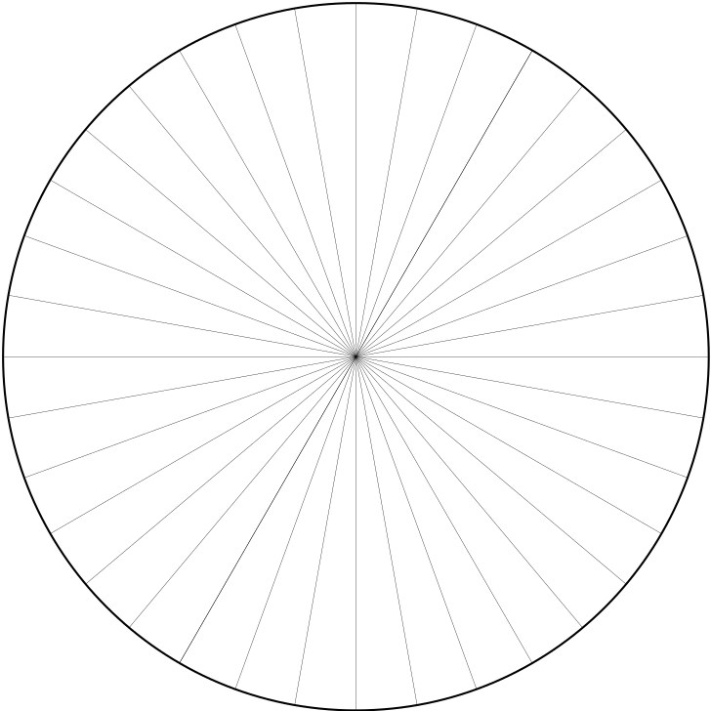
Question 12 [4, 2 = 6 marks]

Rod plays golf at the treacherous Rangeview course. Rod’s scores for his previous 20 games are:

58 64 53 57 52 60 59 49 55 51
57 59 54 54 52 49 53 58 52 50

Calculate the following for Rod’s scores

- Range

- Mode

  - Median

  - Mean

  - Rod plays in a handicap competition. Rod’s handicap is 5.
This means that Rod subtracts 5 from his score each time he plays.

What will the mean of Rod’s “handicap score” be.

Question 13 [2, 2, 4 = 8 marks]

A restaurant offers a buffet meal for large functions. If they charge $25 for adults and $15 for children they can make a total of $6350 for a function of 310 people.

- Let x represent the adults attending. Write an expression about the total number of children at the function, assuming the venue is full.

- Write an equation linking the number of adults and number of children at the restaurant and the total cost for the function.

- Solve the equation to determine how many adults and children attended the function.

Question 14 [1, 1, 2, 2, 2 = 8 marks]
x | -2 | -1 | 0 | 1 | 2 | 3 | 4 | 6 | 9 | B | 56
y | 10.5 | 8 | 5.5 | 3 | 0.5 | -2 | -4.5 | -9.5 | A | -29.5 | C

From the table above, determine the following-

- The gradient

- The y intercept

- The equation of the line

- The values of A, B and C in the table

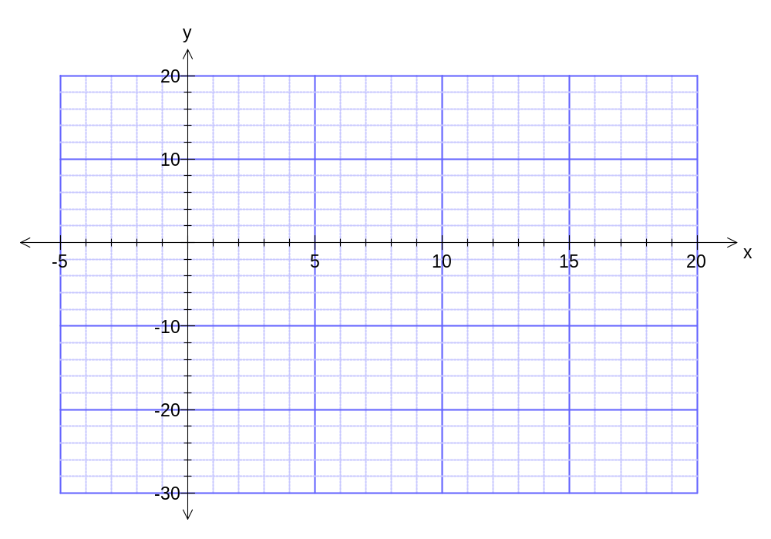
- Plot as many points from the table as possible and draw the line in the graph below.

Question 15 [1, 1, 1 = 3 marks]

A plumber charges a call-out fee for visiting a home plus an hourly rate. For example, if he does a job for 1¾ hours, he will charge the call-out fee plus 1¾ times the rate he charges per hour. The graph below shows the total amount the plumber charges for the time taken to complete the job.
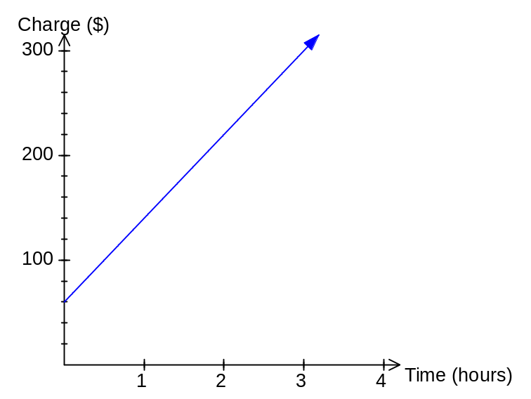
- How much is the call-out fee.

- How much does the plumber charge per hour.

- Determine the equation of the line in the form C = ?t + ?, where C is the total cost and t is the number of hours taken for the job.

END OF QUESTIONS
Additional working space

Question number(s): __________
Additional working space

Question number(s): __________

